ULTRA INTERFACE BUILT WITH A PCB

Tommy N. Tyler 30 November 2002

GENERAL INFORMATION. The fastest, easiest, and most reliable way to build the Ultra Interface is by using a printed circuit board. These instructions contain all the information you need to obtain circuit boards from an internet supplier at reasonable cost.

CONSTRUCTION. All parts are listed below except for the 6-conductor ribbon cable and mating connector for JP1, which have been discussed in numerous previous instructions. The only item that is special is the connector hood, which must be a double-ended type like those used for gender changers that have two connectors. These hoods include an end piece with cable strain relief for use with a single connector. The best internet source for them is B&B Electronics Manufacturing Co. (orders@bb-elec.com, part number BP25AK0020). Jameco Electronics part number 34091 and Radio Shack part number 276-1520 are equivalent.

ITEM REF. DESIG. DESCRIPTION QTY.

1 U1 Integrated Circuit, LM339N 1
2 R1-R5, R8 Resistor, 4.7K, 1/4W 6
3 R6 Resistor, 47K, 1/4W 1
4 R7 Resistor, 100K, 1/4W 1
5 C1, C2 Capacitor, 0.1, 50 VDC 2
6 Connector, DB25 male 1
7 Double-ended Connector Hood, DB25 1

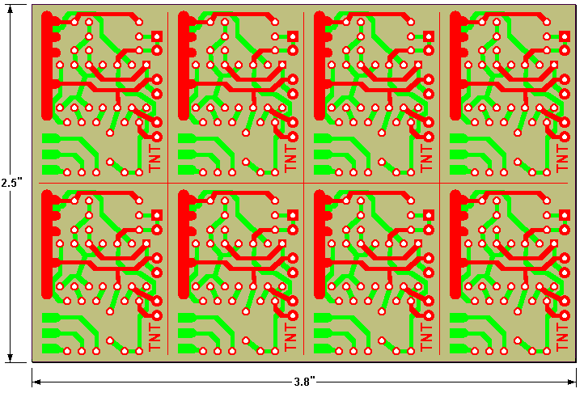

Figure 1. Printed Circuit Panel
Figure 1 shows a PCB panel which has been designed to provide eight individual Ultra circuit boards. The overall board size and layout meets the specifications for the standard Miniboard package offered by ExpressPCB, an internet supplier. That offer is for three 2-sided boards with plated-thru holes, shipped next business day for $62 total. It is suggested that one member buy the panels, cut them into 24 individual boards, and resell them to other members. At a fair price of say $5 each, he would break even by selling at least half the boards. Software for the board is available by e-mail to anyone requesting it.

To use this service, go online to www.expresspcb.com and download the free application software. Place the file for the Ultra board in the same directory, start ExpressPCB.exe, and open the file. Click on Layout>Order Boards Via the Internet, and just follow the instructions to place your order. The whole process of uploading your board file and credit card info takes just a couple of minutes.

Each panel should be cut into eight pieces by sawing along the guide lines with a thin saw blade (e.g., an Exacto saw, or a veneer saw) or by using an abrasive cutting wheel in a Dremel tool. Figure 2 shows the resulting board. The top (component) side circuitry is shown in red and the bottom (solder) side circuitry is shown in green.

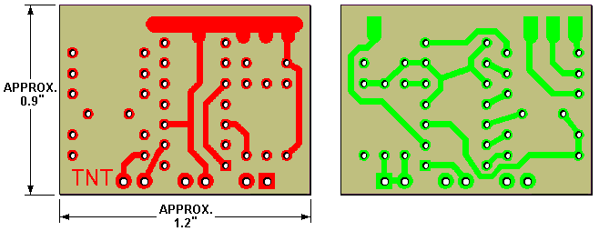

Figure 2. Single Printed Circuit Board

The exact size of the board is not critical. The panel allows generous room between units so that even if your saw cuts are not perfect the boards will be usable. Just cut as close to the line as you can, and avoid cutting into any of the traces or pads on either side.

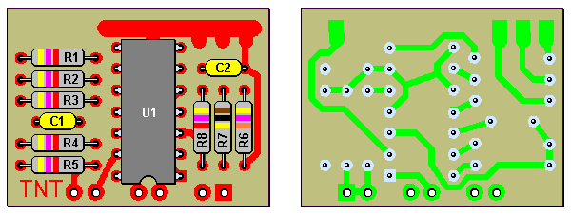

Figure 3. PCB Assembly

Solder all components as shown in Figure 3, and cut the leads within 1/8 inch of the board. It's not necessary to clean soldering flux from the board, but if you want to for esthetic reasons you can do so with denatured alcahol.
Plug the DB25 male connector into a female connector during soldering. The pins are made self-aligning by floating them in the housing, so you need to hold them in the proper position while attaching the board.

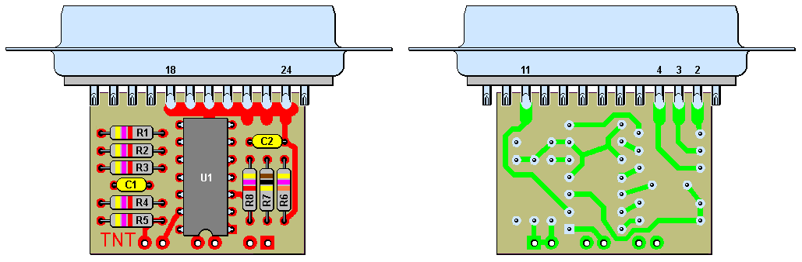

Figure 4. Assembly of Board to Connector

Slide the board between the two rows of connector pins as shown in Figure 4, and leave enough space between the edge of the board and the connector that pin 6 doesn't touch the trace on the bottom side. Center the pads at pins 2 and 11, then solder pins 2, 3, 4, and 11 on the bottom and 18 through 24 on the top.

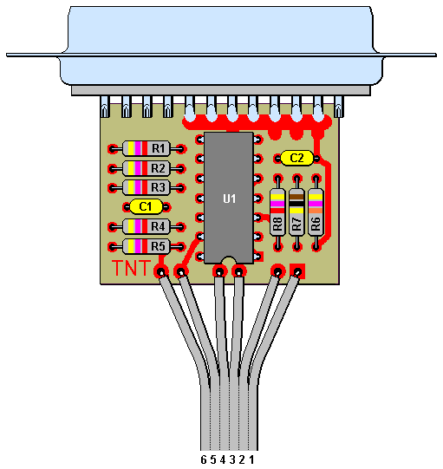

Figure 5. Cable Connection to Edge of Board

Separate the cable wires about an inch back from the end and strip and tin them about 1/8". Solder them to the six
pads along the edge of the board as shown in Figure 5. The wire numbers refer to the pin of the JP1 mating connector they are attached to.

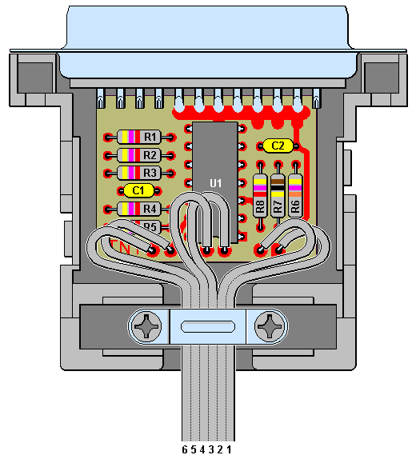

Figure 6. Installation in Connector Hood

Use the cable clamp bracket supplied with the hood for strain relief. If you are using flat ribbon cable you can build up the thickness by wrapping with electrical tape. Also, the bracket will clamp better if you turn it upside down.

TESTING. If this is your first interface, refer to the extensive section on testing and trial download in the instructions for building the Ultra interface on perf board.

