INSTRUCTIONS FOR BUILDING THE ULTRA JP1 INTERFACE
Tommy N. Tyler 30 November 2002

GENERAL DESCRIPTION. The Ultra Interface was designed to provide compatibility between any PC and any remote, eliminating all problems related to voltage mismatch, stuck reset, etc. It operates with standard IR.exe software, and you can operate the remote while it is connected to the interface. The interface draws only about a milliamp from the remote's batteries (which must be installed), so as long as you disconnect the remote from the interface when you are through using it the effect on battery life will be negligible.

PARTS REQUIRED. All parts are listed except for the 6-conductor ribbon cable and mating connector for JP1, which have been discussed in numerous previous instructions. Radio Shack part numbers are given as a point of reference. The only item that is special is item 7, the connector hood. In order for the circuit to fit inside the hood it must be a double-ended hood like those used for gender changers. Identical hoods are available from Jameco Electronics as their part number 34091, and from B&B Electronics Manufacturing Company
(www.orders@bb-elec.com) as their part number BP25AK0020. If your local Radio Shack is typically out of stock on many of the parts, you can buy them all on the internet at www.jameco.com, and the money you'll save will offset the shipping cost. Jameco sells 1/4 watt resistors only in bags of 100, but the cost of a bag is the same as Radio Shack charges for a bag containing just five resistors.

ITEM REF. DESIG. DESCRIPTION QTY. RADIO SHACK P/N

1 U1 Integrated Circuit, LM339N 1 276-1712
2 R1-R5, R8 Resistor, 4.7K, 1/4W 6 271-1330
3 R6 Resistor, 47K, 1/4W 1 271-1342
4 R7 Resistor, 100K, 1/4W 1 271-1347
5 C1, C2 Capacitor, 0.1, 50 VDC 2 272-109
6 Connector, DB25 male 1 276-1547
7 Double-ended Connector Hood, DB25 1 276-1520
8 #30 AWG wire wrap wire 2 feet 278-501, 502, or 503
9 Perf Board, phenolic 1.1" x 1.5" 276-1394, 1395, or 1396

CONSTRUCTION. In order to fit all the components within the connector hood a piece of perf board is converted into a make-shift 2-sided circuit board with thin, bare jumper wires. When a component lead shares a hole with a jumper wire (about 25 places) the lead is always soldered to the jumper wire (top or bottom of board, whichever is easier) and then trimmed about 1/8 inch from the board. (IC leads should be left uncut.) There are five places on the left side and one on the right side where component leads are inserted into empty holes and bent over to be soldered to an IC lead. These component leads can be cut either before or after soldering. In total there are almost 40 solder joints in the assembly. Correcting mistakes is much harder than doing it right, so read and follow each step-by-step instruction very carefully.

 1. (Figure 1) Scribe a piece of phenolic perf board on both sides with a sharp knife, and break off a piece that measures 1.1" x 1.5" ( 11 x 15 holes). Using a piece of sandpaper placed upside down on a table, sandpaper the two long edges down almost to the bottom of the first row of holes. Sandpaper the two short edges down to a point almost half way to the second row of holes. The finished board size will be a little over 1-1/16" x 1-3/8". Enlarge the center six holes along the bottom edge with a 1/16" diameter drill.

 2. (Figure 2) Check the size of the board by sliding it between the solder pins of the DB25 connector and verifying that it will fit within the hood.

 3. (Figure 3) Jumper wires are made by striping all the insulation from pieces of #30 AWG wire-wrapping wire. Do not try to use heavier wire. Stripping this wire isn't simple, and normally requires a small gage wire stripper to avoid putting nicks in the wire. It's usually easier to strip off a few inches at a time, but you can experiment to find the technique that works best for you. You'll need six pieces of various lengths, from about an inch to over six inches. In the figure, RED is wiring on the top side, GREEN is wiring on the bottom side, and the black dots are where the wire passes through the board. Start with the longer patterns D, E, and F, so that if you break a wire you can use the pieces for one of the shorter patterns A, B, or C. As you weave the wires in the patterns shown, keep them snug to the board, but don't pull too hard because the wire breaks easily. And be VERY careful not to allow a loop of wire to twist and kink when pulling it through the board. Except for one, the jumper wire tails need not extend more than 1/4 inch beyond the edges of the board. The tail of jumper wire E at the far right top side is the exception, and should be about 1-1/2 inches long. When you're done, triple check to make sure your wiring matches Figure 3.
 4. (Figure 4) Insert U1 and solder pins 1 through 8 and 10. Place the tip of the soldering iron against both the component lead and the jumper wire passing through the same hole, and make sure the solder makes a joint between the two. As a general rule smaller solder joints are best, but use enough solder so that you're sure the lead and wire are joined.

 5. (Figure 4) Cut away the jumper wire beneath the board between U1 pins 1 and 2. An Exacto knife works well for this if you don't have very sharp nosed wire cutters. Also cut off the two tails of the jumper wires on top of the board from U1 pins 7 and 8.

 6. (Figure 5) Insert R1 and solder both leads. Insert C1 and solder the left lead, then bend the other lead over and solder it to U1 pin 12.

 7. (Figure 5) Before inserting any more components between R1 and C1, cut away the jumper wire beneath the board between U1-12 and the right end of R1.

 8. (Figure 5) Insert R2, R3, R4, and R5 and solder their left leads. Bend their right leads over and solder them to U1 pins 9, 11, 13, and 14 respectively.

 9. (Figure 5) Cut off the tails of four jumper wires from the left ends of R1, R2, R3, and C1.

 10. (Figure 6) Insert C2, R6, R7, and R8. Bend the left lead of R8 over and solder to U1-1, then solder all the other leads. Cut away the jumper wire beneath the board between the left end of C2 and U1-5.

This completes all the board work, and is a good time to double-check your assembly against Figure 6.

 11. (Figure 7) Cut the four jumper wire tails at the upper edge of the board (the green ones in the figure) so they are flush with the edge of the board. Slide the board between the contacts of the DB25 male connector and solder those four jumpers to pins 2, 3, 4, and 11.

 12. (Figure 7) Bend the long jumper wire tail at the upper right corner of the board so it lays across pins 18 through 25 of the connector, and solder it to all eight pins.

 13. (Figure 8) Cable length should be limited to a maximum of 12 feet. Separate the wires of the ribbon cable for a distance of about 1-1/2 inches from the end, then strip and tin each about 1/16 inch. Pull the wires down through the six enlarged holes near the edge of the board as far as they will go. The wire numbers in the figure refer to pin numbers of the JP1 connector. Loop wires 3, 4, 5, and 6 around and solder to U1 pins 12, 1, 13, and 14 respectively. Loop wires 1 and 2 around and solder both to the jumper wire that runs across the board. Make sure that jumper wire isn't touching pins 1 or 14 of U1.

 14. (Figure 9) Place the assembly in the connector hood and attach the cable strain relief. Install the metal clamp supplied with the hood upside down so it extends down between the mounting posts. Improvise small rubber pads about 1/4" x 1/2" and place them above and below the ribbon cable so it is held firmly when the screws of the clamp are tightened.

TESTING. About all you can do at this point is plug it in and see if it works. Be sure the remote has batteries. If you get any error messages go back and check everything. In particular, check that:

a. Pin 1 of the integrated circuit is positioned correctly.
b. All resistors are of correct value and located properly.
c. The connector is not installed upside down.
d. All six cable wires are soldered to the correct places.
e. Wire number 1 of the cable is connected to JP1 mating connector pin 1.
f. The JP1 mating connector is not plugged in upside down or offset to one side.
g. All solder joints look clean and healthy.
h. Three jumper wires beneath the board were cut away in steps 5, 7, and 10.

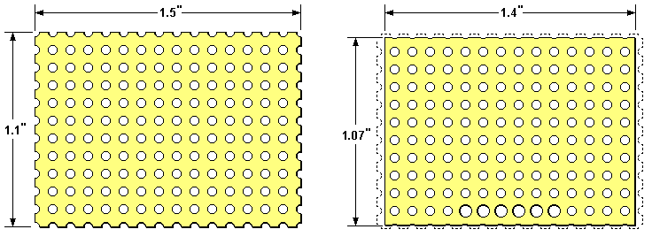

Figure 1. Perf Board Blank and Finished Size

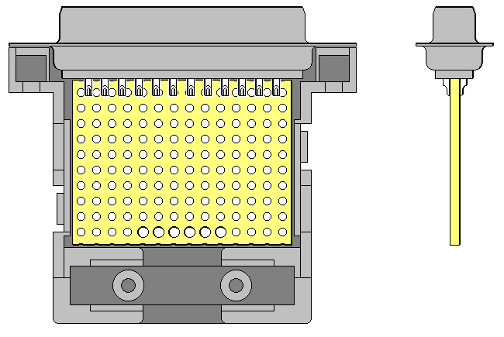

Figure 2. Make Sure Board Fits Within Connector Hood

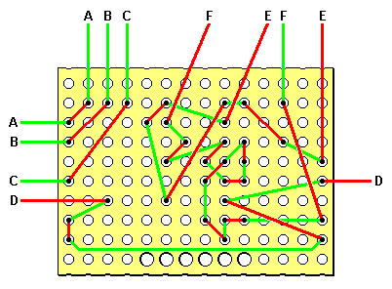

Figure 3. Install Jumper Wires

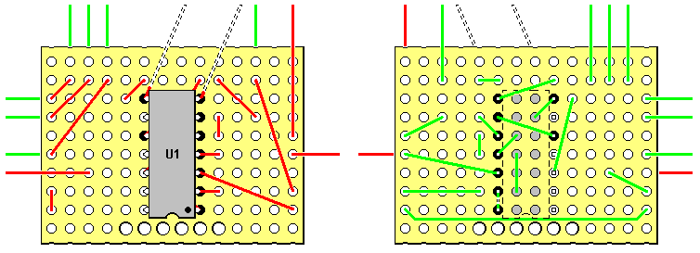

Figure 4. Install Integrated Circuit

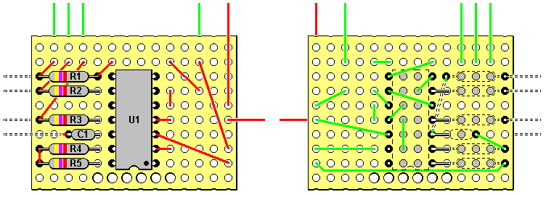

Figure 5. Install Components on Left Side of Board
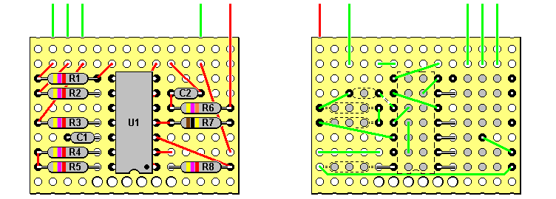

Figure 6. Install Components on Right Side of Board

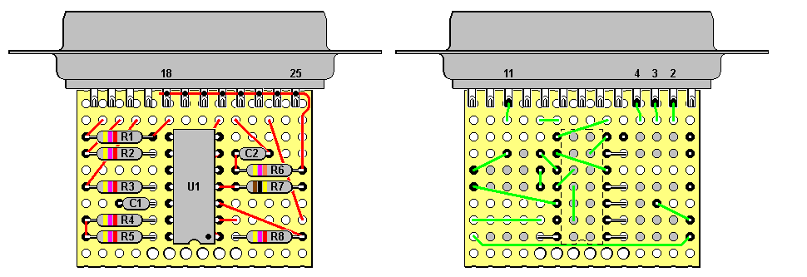

Figure 7. Install DB25 Male Connector

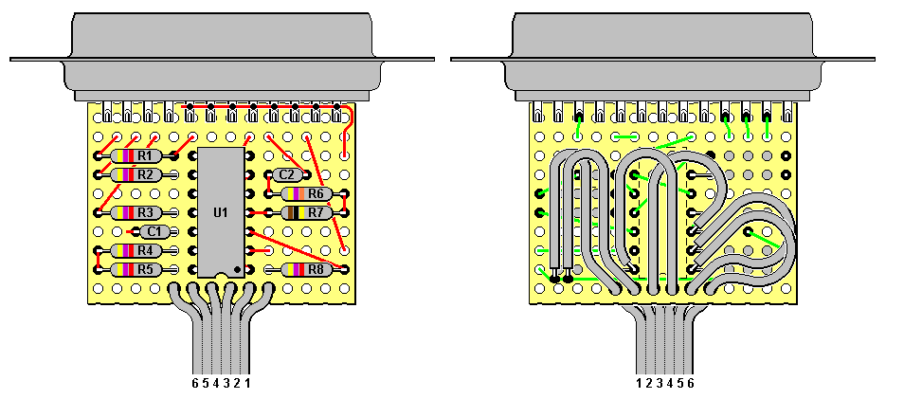

Figure 8. Connect Ribbon Cable to Board

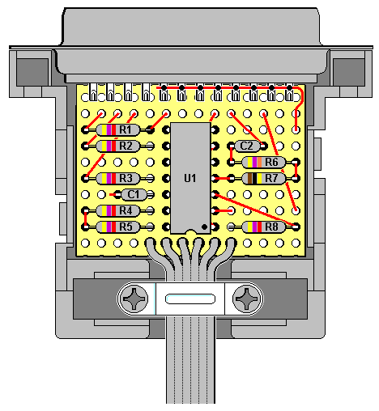

Figure 9. Install Connector and Board Assembly Into Hood

THEORY OF OPERATION. Figure 10 shows a schematic of the interface. U1 is a quad comparator with open collector outputs and an operating voltage range from 2 to 36 volts. All four sections have a reference voltage of about 1/3 of the remote's Vcc voltage applied to their inverting inputs. When a non-inverting input is below the reference voltage the output is pulled down to near ground, and when the input is above the reference voltage the output is open-circuited. R8, R5, and R4 provide pull-up on the SDA, SCL, and RESET lines.

Nearly all PC's have internal pull-ups on their status pins, so the open-collector input to S7 allows that line to swing all the way to the PC's Vcc voltage regardless of the remote's Vcc voltage. Likewise, any PC's output voltage is greater than the comparator reference voltage, so the comparators will switch to the open-collector state and allow the pull-up resistors to raise the inputs all the way to the remote's Vcc voltage regardless of the PC's Vcc voltage. The only common connection between PC and remote is ground.

During standby D0, D1, and D2 are all high, and the resulting battery current is mostly the supply current to U1, typically less than a milliamp.

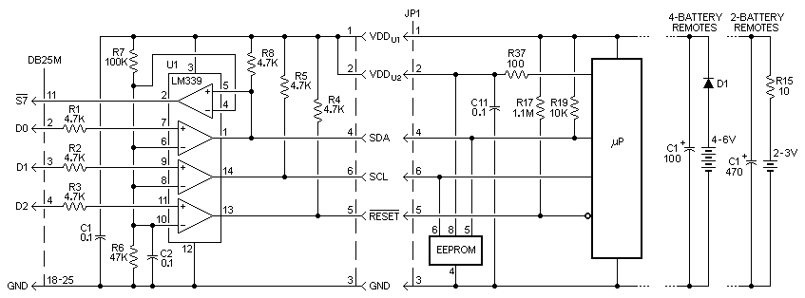

Figure 10. Schematic Diagram of Ultra Interface with Remote Control

