AN IMPROVED USB INTERFACE FOR JP1

By Tommy N. Tyler Version 2.0 10 June 2004

1. INTRODUCTION. The first generation USB Interface released in early December 2003 has been found to have some potential problems in its design. These instructions describe how to build an improved USB Interface that should eliminate all hardware-related problems. The new design is fully compatible with IR.exe software versions 4.02 or later. Although some remotes may upload or download without batteries, all remotes will do so with batteries, as well as remaining fully functional while connected to the interface. For any of you who have already built or purchased a USB Interface and are experiencing trouble, a separate illustrated article will be released that shows how to upgrade those units to the new configuration.

2. PARTS REQUIRED. For parts and shipping you should budget about $30 for the project. All parts in the following list except item 1 are available from Mouser Electronics (www.mouser.com). Item 1 is a special microcomputer that must be purchased from Delcom Engineering (www.delcom-eng.com). It contains a proprietary program that enables the PC to transmit and receive in a format compatible with the remote's 2-wire serial EEPROM. Delcom also sells item 8, (803504), and a kit containing items 2, 3, 4, and 6, (803507), but their prices are higher than Mouser's.

ITEM DESCRIPTION QTY CAT. PG. STOCK NO. PRICE
1. Integrated Circuit, Delcom Engineering (U1) 1 --- 802300 $8.00
2. Ceramic Resonator, 6 MHz (Y1) 1 536 520-ZTA600MT .36
3. Capacitor, Monolythic, 0.1 MFD (C1) 1 514 75-1C10Z5U104M050B .10
4. Capacitor, Tantalum, 4.7 MFD (C2) 1 474 581-TAP475K010SCS .40
5. Resistor, 1/4W, 10K 5% (R1, R2, & R3) 3 387 30BJ250-10K .66
6. Resistor, 1/4 W, 7.5K 1% (R4) 1 383 71-RN60D-F-7.5K .21
7. IDC Connector, 6-pin Female 1 unlisted 649-71602-306 .67
8. USB Cable, 6 ft. 1 703 172-1024 2.70
9. IC Socket, 20-pin 1 828 575-199320 .48
10. Box, 1-3/8" x 2" x 3/4", Hammond 1551Gxx 1 1105 546-1551Gxx 1.03
( xx = BK for black, GY for gray)
11. Small piece of perf board (see text) 1
12. 6-conductor cable, 4 to 10 feet long (see text) 1

3. CABLE PREPARATION. The interface uses two cables. One of these (item 8) connects the interface to your PC. It is made from a standard 4-conductor USB cable with a Type "A" connector at one end and Type "B" connector at the other. Cut off and discard the Type "B" connector (the smaller one). Strip away the outer jacket and shielding about 2-1/2 inches, but do not strip the individual wires until you are ready to attach it to the board.

The other cable connects the remote to the interface, and requires a little more work. All JP1-compatible remotes have a T-shaped access hole in the battery compartment for the 6-pin JP1 connector, as shown generically in Figure 1. Sometimes the opening is at the forward end of the compartment, and sometimes at the rear, but in either case the vertical bar of the "T" always points toward the rear or lower end of the remote. It serves as a sort of clearance slot for the cable wires that exit the lower edge of the connector.

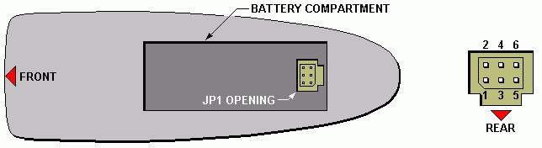

Figure 1. Orientation of JP1 Connector in a Typical Remote
The six pins are always positioned in the opening as shown in the right hand detail of Figure 1. The pin numbers are not marked on the board, but sometimes there's a printed rectangle with the corner nearest pin 1 chamfered. Our objective is to wire the connector so that the cable approaches from the side having pins 1, 3, and 5. Then whenever you plug it into any remote, regardless of location or orientation of JP1, you can mentally associate the cable wires with the vertical bar of the "T" and be assured of correct orientation.

These instructions describe a cable built the easy way, using a 6-pin IDC connector (item 7) and a piece of flat ribbon cable six conductors wide. If you search the archived messages you'll find other cable construction suggestions as well. Some of these use connectors with solder or individual crimp type pins, and there are 2-row connectors fabricated by cementing two single-row connectors together. Just make sure the connector you use mates with a dual-row header having 0.025" square pins on 0.1" centers, and that it will pass through the opening for JP1 in the remote's battery compartment. And if you ever have to solder to one of these connectors, either the male pins or the female contacts, temporarily plug in a mating connector to hold the pins or contacts in position so they won't become misaligned when heat from the soldering iron softens the plastic.

Whatever 6-conductor cable you use should be an unshielded type with stranded wires, not solid. The size of the wires should be either #28 AWG with 7/36 stranding or #26 AWG wires with 7/34 stranding. One problem with standard ribbon cable is that suppliers (including Mouser) prefer to sell it by the spool, and you only need a few feet. You may be able to salvage enough from an old computer drive cable.

Probably the best alternative to flat ribbon cable is 6-conductor flat modular telephone cable. It's very tough, yet extremely flexible. And another good thing, Mouser sells it by the foot in either black, white, or silver. (See catalog page 704, stock number 172-UL6210.) The individual wires in this cable lie in a flat row, but their insulation diameter is a little smaller than that of ribbon cable wires. So when you insert it into item 7 be sure to spread the wires slightly so they line up with the notches in the connector.

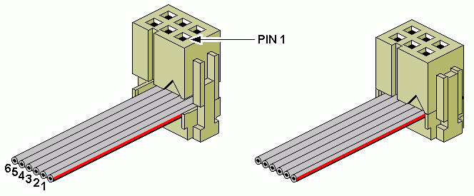

Figure 2. Assembling an IDC Connector Without Strain Relief

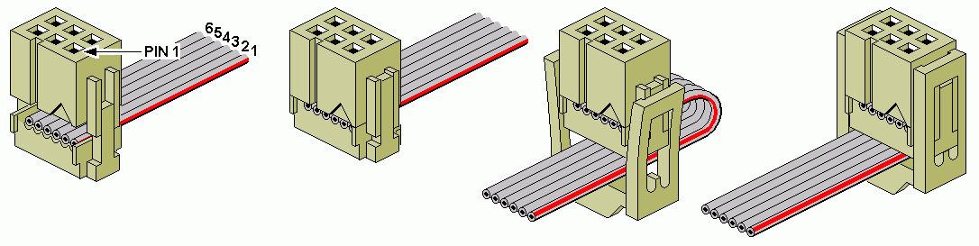

Figure 3. Assembling an IDC Connector With Strain Relief

Figures 2 and 3 show how to attach the ribbon cable to an IDC connector with and without a strain relief. The wire numbers have no significance until they are soldered to the board later, but for your reference they correspond to pins of the connector they make contact with. Cut one end of the ribbon cable clean and square and insert it flush with the edge of the connector. Make sure the wires line up with the notches, then squeeze the two halves together until both retainer loops snap over the ribs and lie flat against the sides. At the other end of the cable, separate the wires for a distance of about 2 inches, but do not strip the ends yet.

4. BOARD PREPARATION. The interface is built on a piece of perf board (item 12, also called Vector board, project board, etc.) Start by cutting a rectangle 1.2" wide by 1.3" long (12 holes x 13 holes) as shown in Figure 4. Check the fit of the board in the box, and sandpaper the edges if necessary.

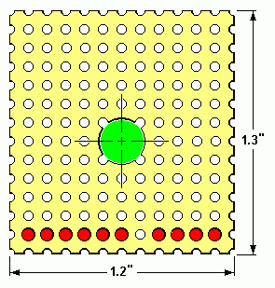

Figure 4. Blank Perf Board

Enlarge the ten holes shown in red with a 1/16" drill bit. Disregard the enlarged hole shown in green in Figure 4 if you use the recommended box, item 10 in the parts list. If you are gathering your parts from sources other than Mouser there is an alternate box you can use, Radio Shack part number 270-288, ($1.99). That box has a post in the center, so you must enlarge the center hole in the board with a 1/4" drill bit, and keep all wiring clear of that hole as shown in the assembly drawings that follow.

5. COMPONENT ASSEMBLY. Figure 5 shows component placement. Pins 4, 5, 6, 9, and 15 through 20 of the IC socket are not used, and you can cut them off if you want to. Use a little glue to hold the socket in place during

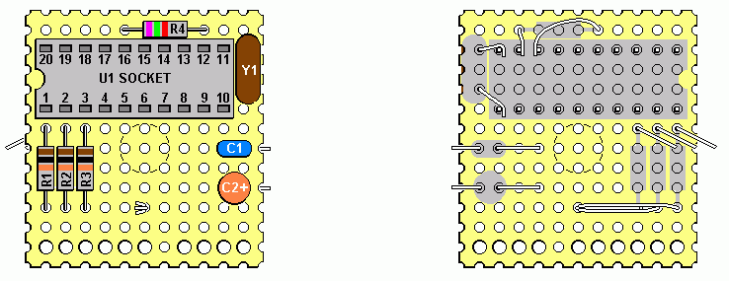 TOP VIEW BOTTOM VIEW
Figure 5. Component Assembly
soldering. Bend all resistor leads to a spacing of four holes. Insert resistors R1, R2, and R3, and temporarily bend the upper leads over in any direction to hold them in place. Bundle the three lower leads together and route them, straight across and up through a hole as shown. Bend them down against the top of the board to lock them in place, and cut them off close to the edge of the hole.

Insert resistor R4 and solder its leads to pins 12 and 13 of the socket. Insert resonator Y1 and solder its leads to pins 10 and 11 of the socket. (Bend the resonator and socket leads toward each other to make them reach.) Look carefully at the printing on capacitor C2 to determine the positive terminal, which must be oriented toward the edge of the board. Insert both capacitors and spread their leads temporarily to hold them in place.

6. CONNECTING USB CABLE TO BOARD. Pass the wires of the USB cable through the row of four enlarged holes, as shown in Figure 6, leaving about 1/2 inch between the end of the cable jacket and the edge of the board.

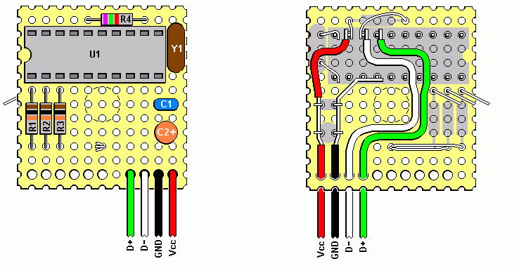

Figure 6. USB Cable Connections

Lay the BLACK wire along the path shown so you can cut it to the correct length. Strip off about 1/2 inch of insulation so the bare wire will make contact with the capacitor leads and IC socket pins. Hook the capacitor leads over the wire and solder them. Then solder the end of the wire to pins 7 and 8 of the socket.

Likewise, lay the RED wire along its path and cut it to length. If you can expose just enough bare wire for contact with the leads of C1 and C2, the remaining RED insulation wil prevent shorting to the resonator leads. As an alternative you can just strip off about 1 inch of insulation, tin the bare wire so it will hold its shape, and route it carefully from C1 to U1 so that it doesn't touch the resonator leads. Hook the capacitor leads over the wire and solder them. Then solder the end of the wire to pin 12 of the IC socket, along with the lead from R4.

The round-about routing of the GREEN and WHITE wires shown in Figure 6 is to clear the 1/4 inch hole in the center of the board, in case you are using the alternate Radio Shack box. If you are using the Mouser box you don't have to avoid that area in the center of the board. Cut the wires to length, solder the GREEN wire to pin 14 of the IC socket, and solder the WHITE wire to pin 13, along with the lead from R4.

7. CONNECTING JP1 CABLE TO BOARD. Referring to Figures 1, 2, and 3, carefully identify the connector pin numbers associated with the wires of the 6-conductor cable, and pass them through the row of enlarged holes in the numerical order shown in Figure 7. Note that wires 4 and 5 must be swapped over each other before they enter the board, so that the wire from JP1 pin 4 goes to U1 pin 2 and the wire from JP1 pin 5 goes to U1 pin 3.
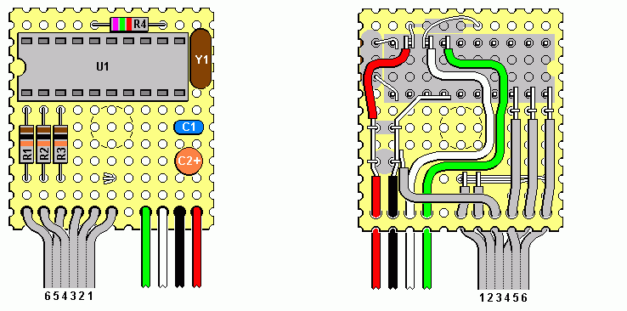
Figure 7. JP1 Cable Connections

Check and double-check to be sure all the JP1 cable wires are connected to the circuit where shown. If you're not absolutely sure of which is which you should make a continuity test from the board to the appropriate pins of the connector. This the the most critical step of assembly, and the place where most errors are made.

Cut wires 1 and 2 to length and solder them to the three resistor leads. Route wire 3 as shown, cut it to length, and solder it to the BLACK ground wire. Cut wires 4, 5, and 6 so they reach pins 2, 3, and 1 of the IC socket, and strip about 1/4 inch of insulation from the ends. Hook each resistor lead over its corresponding wire and solder the wire to both the resistor lead and IC pin.

After you have completed the board and cable assembly make a final check of your work against Figure 7 to be sure all connections are as shown, all joints are well soldered, and that there are no accidental shorts.

8. FINAL ASSEMBLY. Very carefully plug the integrated circuit U1 into its socket, making sure that pin 1 faces toward the three resistors, as shown in Figure 8. It's much easier to insert the IC if you bend the pins inward slightly so they line up with the socket holes. The board can just lie loose inside the box. Cut or file notches in the edges of the box to clear the cables. With the cable wires passing through holes in the board, a strain relief such as the tie-wrap shown in Figure 8 is really unnecessary. Fasten the lid to the box and you're ready for testing.

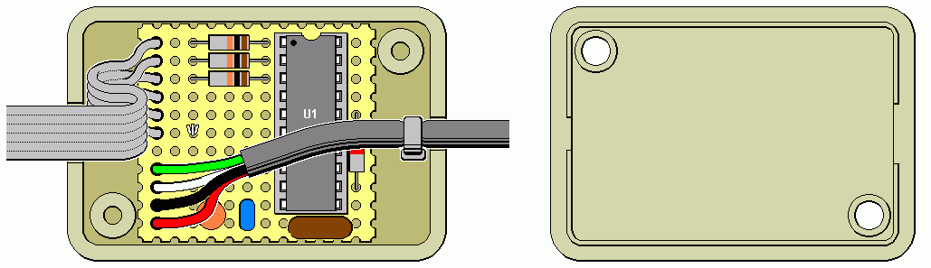

Figure 8. Final assembly in Mouser Box

Figure 9 shows the board and cable assembly placed over the center post in the alternate Radio Shack box.

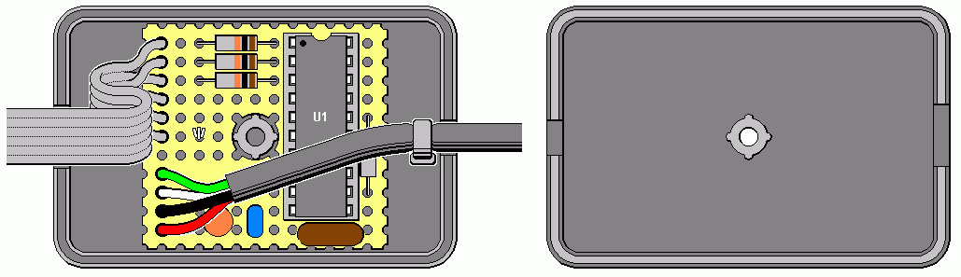

Figure 9. Final Assembly in Radio Shack Box

Download IR40x or IR50x from the JP1 site, and be sure to place the latest collection of RDF files in the same directory. Also download the two Delcom files called USBIODS.sys and USBIODS.inf . Place the .sys file in the WINDOWS/SYSTEM32/DRIVERS directory, and place the .inf file in the WINDOWS/INF directory.

6. How It Works. Figure 10 shows a schematic of the new design. Most of the work is done by microcomputer U1, which is programmed to pass data back and forth between the PC (over the GRN and WHT wire pair) and the remote (over the SDA and SCL lines). U1 holds the RESET line low during upload and download, to immobilize the remote's processor so it won't fight for control of SDA and SCL. During standby the RESET line remains high, and the remote is fully operational.

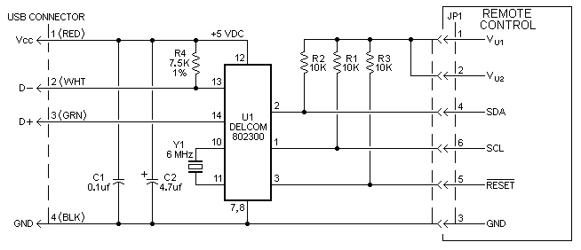

Figure 10. Schematic of Improved USB Interface

The USB port supplies 5VDC operating power for U1 over the RED and BLK wire pair. U1 pin 2 is configured as an output when U1 is sending data to the remote, and as an input when it is receiving data. When used as outputs, U1 pins 1, 2, and 3 will source about 0.3 mA or sink about 1.5 mA. Resistors R1, R2, and R3 ensure that the signal lines swing fully positive if the remote's operating voltage is greater than that of the interface.

U1 transmits and receives data in 8-byte packets rather than 16-byte packets as with Serial and Parallel interfaces, so it is a little slower uploading and downloading.

