HOW TO BUILD A SERIAL PORT INTERFACE FOR JP1

By Tommy N. Tyler Version 1.0 12/6/03

1. INTRODUCTION. Starting with version 4.00, IR.exe added support for serial and USB ports in addition to parallel ports. Here's a new interface designed especially for use with a serial port. It is compatible with output voltages of +/− 5 volts to +/− 15 volts, which covers every type of PC made. It works reliably with remotes under any battery conditions, from 2-cell models with weak batteries to 4-cell models with brand new batteries. These instructions describe how to build the interface using either perf board or a printed circuit. Both versions are built with a DB9 female connector, so if your serial port is an older type that uses a 25-pin connector you must add a DB25-to-DB9 adapter.

2. PARTS REQUIRED. The following list from Mouser Catalog Number 616 includes everything you will need for the project. WARNING: Do not try to substitute a 74HCT03 or any other type of device for U1 (item 2).

ITEM DESCRIPTION QTY CAT. PG. STOCK NO. PRICE

1. DB9F Connector, right-angle, PCB mount (P1) 1 662 152-3409 $.95
2. Integrated Circuit, 74HC03 (U1) 1 207 511-M74HC03 .34
3. IC Socket, 14-pin (recommended) 1 746 575-199314 .34
4. Transistor, 2N3904 or any NPN type (Q1) 1 305 511-2N3904 .06
5. Resistor, 1/4 W, 1.5K (R1) 1 376 30BJ250-1.5K .22
6. Resistor, 1/4W, 4.7K (R3, R7, & R8) 3 376 30BJ250-4.7K .66
7. Resistor, 1/4W, 10K (R4, R5, & R6) 3 376 30BJ250-10K .66
8. Resistor, 1/4W, 27K (R2) 1 376 30BJ250-27K .22
9. Capacitor, Monolythic, 0.1 MFD, 50V (C1) 1 482 75-1C10Z5U104M050B .10
10. 6-pin IDC connector 1 --- 649-71602-306 .67
11. 1.2" x 2" piece of perf board, or a PCB 1 --- --- ---
12. 4 to 15 feet of 6-conductor flat ribbon cable 1 --- --- ---

3. PERF BOARD CONSTRUCTION. Score and break a piece of perf board 1.2" wide by 2.0" long (12 holes x 20 holes). Enlarge six holes to 1/16" diameter and four to 1/8" diameter, as shown in Figure 1.

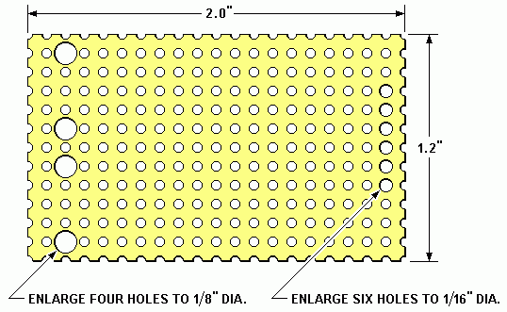
Figure 1. Blank Perf Board

Start by installing the DB9 connector and integrated circuit socket as shown in Figure 2. The pin spacing of a DB9 right-angle PCB mount connector is not a direct fit to the 1/10" x 1/10" hole spacing of perf board, but the 1/8" diameter holes take care of that. Insert the connector so that pins 6 and 7 pass through one of the two 1/8" holes, and pins 8 and 9 through the other. Pins 1-5 will pass through the five holes in the next row if you bend them very slightly toward the center.
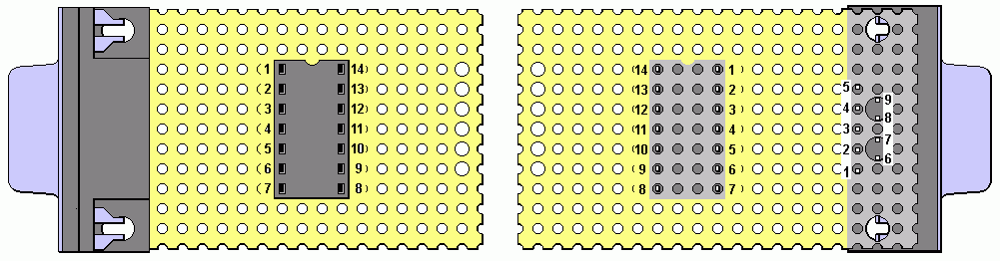
Figure 2. Placement of IC Socket and DB9 Connector

There are any number of ways to secure the DB9 connector to the board. You can bend the pins over, put a small blob of solder on each, or discard the spring clips and use a pair of #4-40 screws and nuts. My preference is to use a few drops of super glue, and that works for the socket as well.

The following details show parts placement and wiring that makes maximum use of component leads for the initial interconnections. This minimizes the number of extra jumper wires needed to complete the assembly. Feel free to modify the arrangement if you see a way to improve it or make soldering easier.

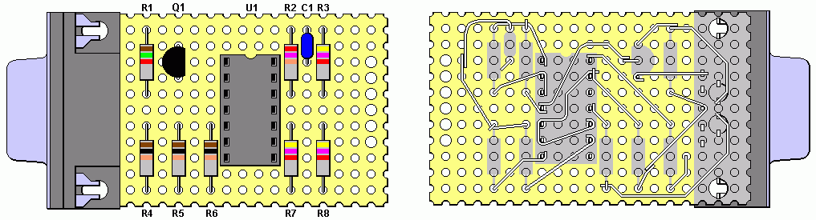
Figure 3. Initial Wiring

Prepare all resistors by bending the leads on 0.4" centers, then insert them where shown in Figure 3. Make sure of your component values because changing them later will be messy. R1 is the only 1.5K and R2 is the only 27K. R3, R7, and R8 are 4.7K and R4, R5, and R6 are 10K. Route the leads as shown in the underneath view of Figure 3 and solder them everywhere they are shown touching. Cut-off resistor leads are handy for extra wire where necessary. At this stage of assembly the lower lead of C1 is not yet connected to anything.

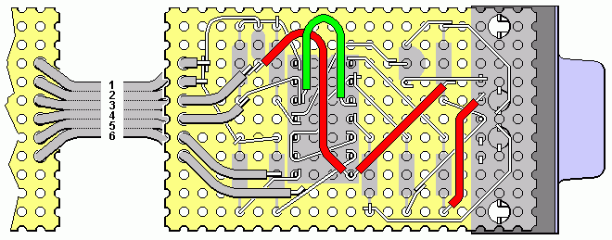
Figure 4. Finished Wiring
Figure 4 shows the completed wiring, using four insulated jumpers to prevent shorting to the bare wires or to themselves. These can be made from solid buss wire and sleeving, or with insulated wire (the smaller the gage the better, and solid is better than stranded). The colors of the jumpers in the illustration have no significance. The wire numbers of the flat ribbon cable correspond to pin numbers of the mating JP1 connector. Separate the six wires about 1" back from the end and pass them through the enlarged holes in the board. Then cut to desired length and strip and tin the ends. Solder both wires number 1 and 2 to the bare wires connecting R2, C1, R3, R7, and R8. The cable can be up to 15 feet long if you want. If you are using something other than ribbon cable just be sure the pins are connected according to the numbers in Figure 4.

After you have soldered all connections, make a final check of your assembly against Figure 4. Be sure all joints are well soldered, and that there are no shorts between wires that are not shown connected. Then insert U1 into its socket with pins 1 and 14 toward the upper edge of the board.

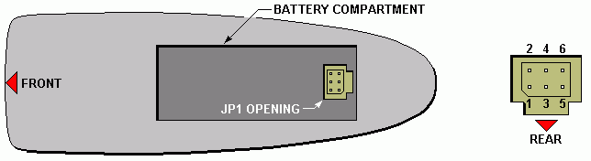
Figure 5. Orientation of JP1 Connector in a Typical Remote

JP1-compatible remotes have a T-shaped access hole in the battery compartment for the 6-pin JP1 connector, as shown generically in Figure 5. Sometimes it is at the forward end of the compartment, and sometimes at the rear, but in either case the vertical bar of the "T" always points toward the rear or lower end of the remote, and serves as a sort of (unnecessary) clearance slot for the connector cable. The six pins are always positioned as shown in the right hand detail of Figure 5. The pin numbers are seldom marked on the board, but often there's a printed rectangle with the corner nearest pin 1 chamfered. Our objective is to install the connector so that the cable approaches from the rear end of the remote. Then whenever you plug it into any remote you can mentally associate the cable wires with the vertical bar of the "T" and be assured of correct orientation.

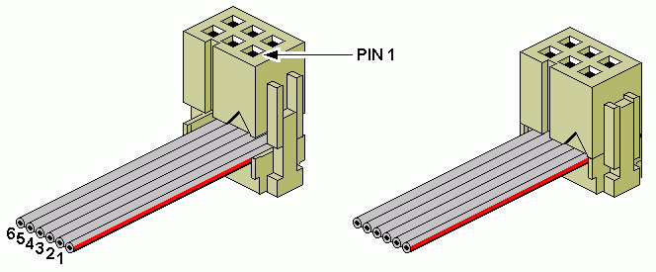
Figure 6. Assembling IDC Connector Without Strain Relief

Cut the end of the cable clean and square. If you're not going to use a snap-on strain relief the cable should enter the connector from the rear as shown in Figure 6, with wire number 1 (shown with a red stripe in the illustration) toward the corner socket that will mate with pin 1. Squeeze the two halves of the connector together carefully until the parts latch. If you are using a connector with solder pins or crimp pins refer to Figures 5 and 6 to make sure it is terminated correctly.

When using an IDC connector with a snap-on strain relief, wire number 1 should still be toward the corner socket that will mate with pin 1, but the cable should enter the connector from the front so that after folding it back under
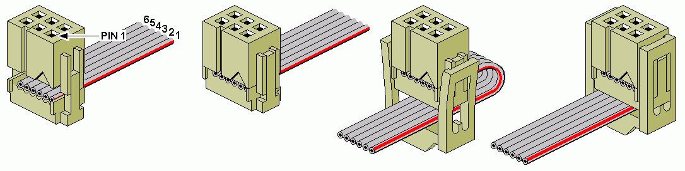
Figure 7. Assembling IDC Connector With Strain Relief

the strain relief it will lie along the vertical bar of the "T" opening when plugged into the remote. Figure 7 shows the brand of connector sold by Mouser, on which pin 1 is identified with a ▲ symbol. Place the cable in the connector so that the end of wire number 1 is right below the ▲ symbol, then squeeze the connector together carefully until the parts latch. Wrap the cable back over the top and under the strain relief and hold it as tightly as you can while you press the strain relief down until the loops snap over the ribs on the sides of the connector.

4. PRINTED CIRCUIT CONSTRUCTION. Attached to this article is a printed circuit board file (ExpressPCB format) entitled Serial4Panel.pcb. It is layed out as a panel of four boards on ExpressPCB's standard 2.50" x 3.80" Miniboard, so that a standard order for three Miniboards ($59 including shipping, as of this date) provides 12 boards when cut apart. Figure 8 shows an example of an individual board, with red traces on the top (component) side, gray traces on the bottom (solder) side, and plated-through holes.

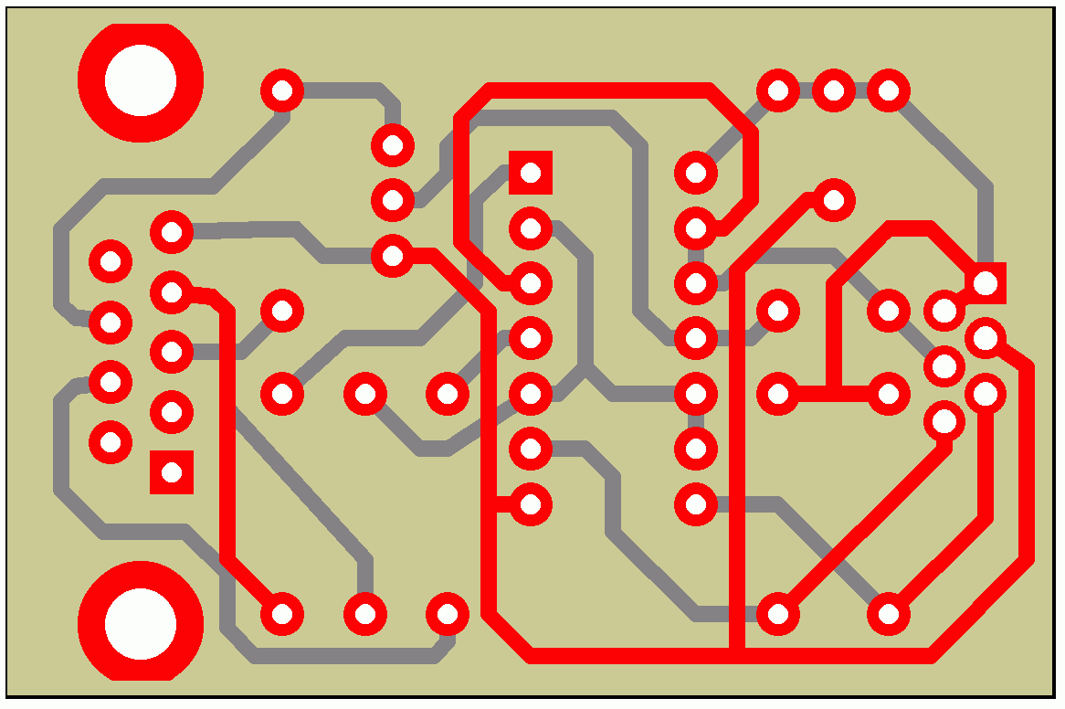
Figure 8. Printed Circuit Board Cut from Panel of Four

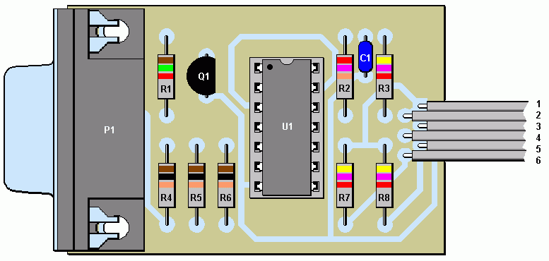
Figure 9. Circuit Board Assembly

Figure 9 shows the completed PC board assembly. Make the cable as long as you want. Cut the ends of the odd numbered wires about 1/16" shorter than the others, strip and tin all six, then solder them to the board.
5. PACKAGING. It's not necessary to put the unit in a box unless you're a stickler for appearance. It works fine just as a bare board, especially the printed circuit version. When plugged into the back of a PC it is reasonably safe from short circuits and static electricity. For the perf board version you might want to use a few discretionary dabs of hot glue to hold the jumpers snugly against the board. Or just wrap the board tightly with electrical tape after first wrapping it with paper or Saran wrap in case you might want to remove the tape some day.

A method I like that provides good protection for the board is to coat both sides with several generous layers of liquid vinyl electrical insulation, such as is sold in the electrical department of Home Depot and other hardware stores. This provides a conformal coating that covers the unit with a thick layer of tough, flexible insulation and buries the jumpers so the unit can be handled without damaging anything or pulling anything loose. If you use this method cut all soldered leads and pins as close to the bottom of the board as possible to minimize sharp projections, and test the unit thoroughly to make sure it works before applying the insulation.

6. HOW IT WORKS. For those who are curious and able to understand it, Figure 10 shows a schematic of the interface. There's no UART chip used because the design doesn't rely on conventional serial communications.

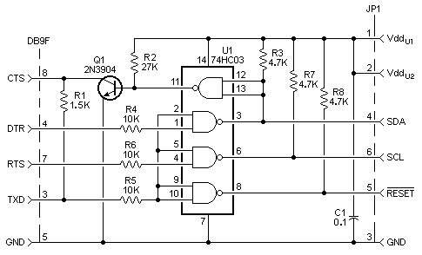
Figure 10. Schematic of Serial Interface

Instead, the PC uses the Transmit Data (TXD) line and two handshake lines, Data Terminal Ready (DTR), and Request To Send (RTS), to control RESET, SDA, and SCL signals to the EEPROM. And it uses the Clear To Send (CTS) status input to receive data on the SDA line from the EEPROM. Manipulating these lines is just a matter of reading and writing to registers associated with the serial com port being used. U1 is a high-speed CMOS chip with open drain outputs, which satisfies the "wired OR" requirements for the three signal lines to the remote. R3, R7, and R8 provide pull-up to the remote's Vdd, which is why it works with any remote battery voltage. U1 will operate at voltages from 2 to 7 VDC. During standby, DTR, RTS, and TXD are all low, and the remote's processor has full control over SDA, SCL, and RESET. When TXD is held high to reset the remote during upload or download, it provides a pull-up voltage through R1 for the CTS input. The TXD input also enables the DTR and RTS inputs. That prevents contention on the SDA or SCL lines if a PC initializes with TXD low and either DTR or RTS high.

In the RS232 specification that defines serial port voltage levels, a logic "1" is defined as at least +5 volts, but not more positive than +15 volts, and a logic "0" is defined as at least −5 volts, but not more negative than −15 volts. My Dell desktop, which is pretty representative, swings from −10 volts to +10 volts. U1 has internal clamping diodes to Vcc and ground on all inputs, to protect against electrostatic discharge. These diodes are used in this circuit to protect the inputs from the large voltage swings of serial port output signals. The diodes have a 20 mA clamping current rating, and R4, R5, and R6 safely limit the current to less than 10% of this.

The interface draws less than 1/4 milliamp from the remote during standby, so using it for extended periods of time will have little effect on battery life. Some PC's leave one or more of their serial port outputs high when inactive, which can increase the battery drain slightly. If your remote is inoperable after exiting IR until you unplug it, that's probably the reason. In that case don't leave it connected to the interface indefinitely.

