Making a 6-pin JP1 Connector from a Disk Drive Cable

Tommy N. Tyler April 8, 2001

IDC connector cables for disk drives are a good source for making a 6-pin JP1 connector. They come in different sizes, from 30 to 50 conductors, and from 12 inches to 36 inches long, as shown in Figure 1. Use the longest one you can get.
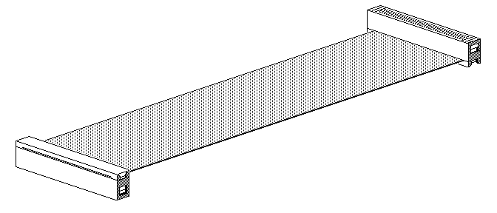
Figure 1. Typical IDC Cable

These cables are very inexpensive, and can often be found on sale at electronics discount stores such as MCM for less than a dollar. They are made with flat ribbon cable, which is a row of #28 gage wires spaced 20 to an inch. Figure 2 shows how the connector is made in two parts. The contacts in the main body extend out as tiny barbs. To assemble the connector the cable is laid on these barbs and the two halves are squeezed together like a sandwich. The barbs pierce the insulation and make contact with the wires, while the hooks at each end of the connector engage to hold it all tightly together. The ability to terminate so many wires simultaneously is the key to low cost.

The tools needed for this job are wire cutters, a sharp Exacto knife, and an Exacto modeler's saw No. 35. This saw has a very thin blade with extremely fine teeth, and does a much better job than a Dremel saw. Start by cutting the cable wires close to one of the connectors. If your cable has a small group of wires separated and given a half twist at one end, cut off the connector at that end.

Holding the connector in a small vice with cable attached, saw through the connector between the 2nd and 3rd wires. Try to saw as straight as possible, but don't worry about slight damage to the wires or contacts at the saw cut as these will be discarded later. Then saw again between the 12th and 13th wires. This will provide a connector about 1/2 inch long having ten wires, as shown in Figure 3. Scrape all sawed edges with the Exacto knife to remove cutting burrs.

Make two small slits in the end of the cable and peel off the two wires at each side, leaving a 6-conductor cable in the center as shown in Figure 4. The two barbed contacts at each end will probably come out with the wires, but if they don't, pull them out with pliers. Reassemble the connector with epoxy, liquid nails, or hot melt glue, applying cement to the six wires and contacts as well as the area at each end where wires were removed. Turn the connector over, and using a small wooden toothpick place a small amount of cement inside each of the two empty contact holes at each end. It is suggested that you place a small piece of masking tape over the six center holes so cement won't get into them. If that happens you'll be glad your original connector is long enough to saw off another 1/2 inch piece and start over.

It is recommended that you also cement a small plastic strip to the connector to act as a handle for reaching down into the remote to plug it in. That way you don't have to pull on the wires to unplug it.

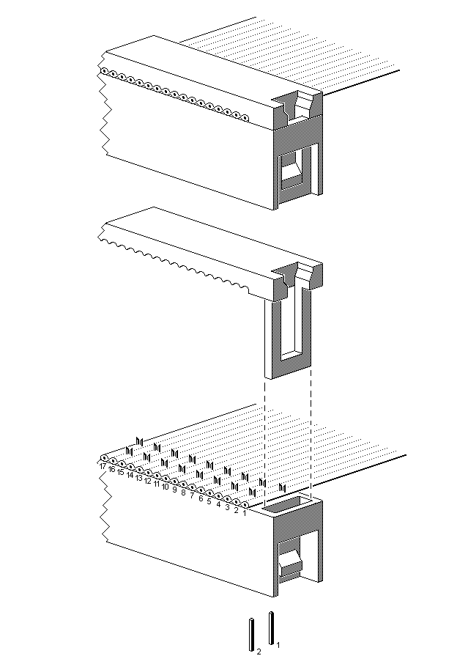
Figure 2. Typical IDC Connector Assembly

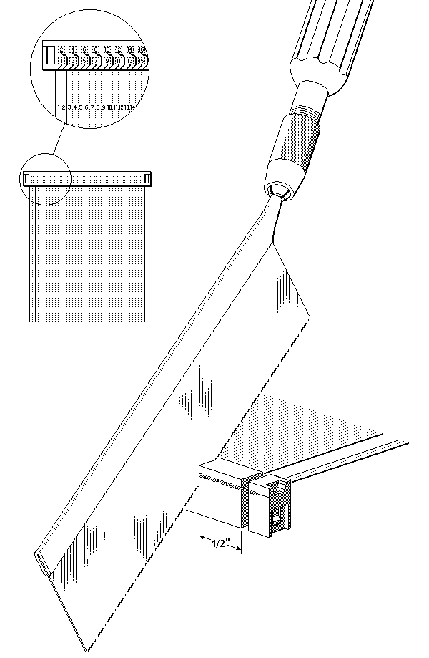
Figure 3. Sawing Connector to Length

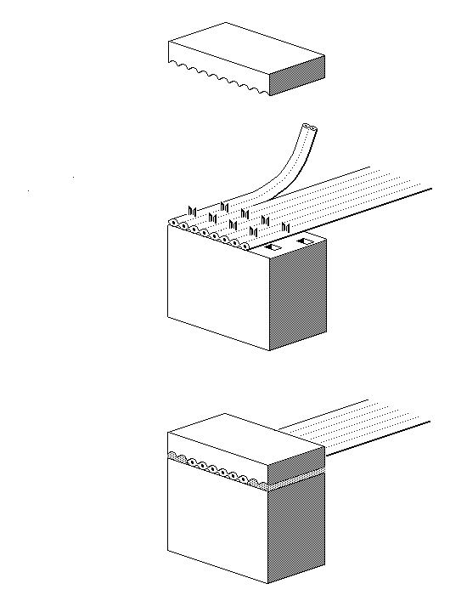
Figure 4. Reassembling Connector with Cement

